Black Box Testing

David Lambertson

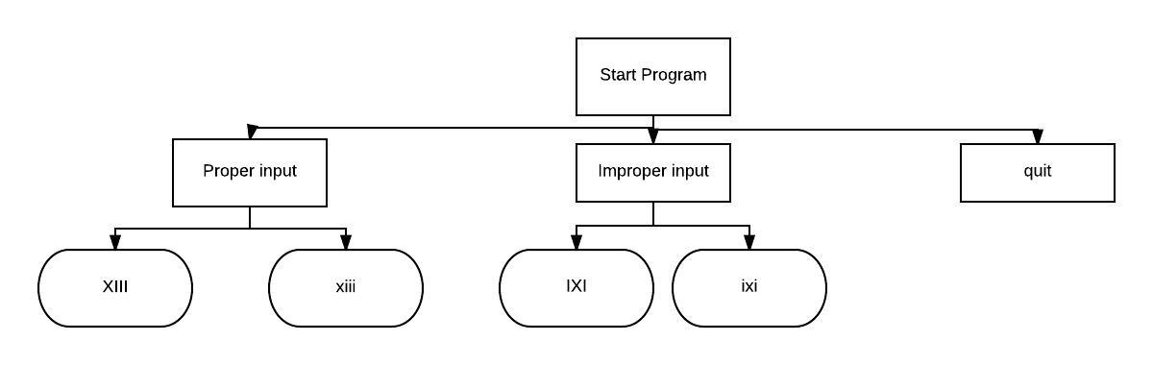

Figure Testing Cases

**Proper Input**

**Test**: Upper Case

Steps:

* Start the program
* Enter ‘XIII’
* Wait for response

Expected output: Valid

**Test:** Lower Case

Steps:

* Start program
* Enter “xiii’
* Wait for response

Expected Output: Valid

**Improper Input**

**Test:** Upper Case

Steps:

* Start program
* Enter ‘IXI’
* Wait for response

Expected output: invalid

**Test:** Lower case

Steps:

* Start program
* Enter ‘ixi’
* Wait for response

Expected output: invalid

**Quit**

**Test:** End program

Steps:

* Start program
* Run other tests
* Enter ‘quit’
* Leave

Expected output: None